1. Program to implement Audio and Video features for your web page

Ans :

<!DOCTYPE html>
<html><head>
<title>Audio and Video Demo</title>
<link rel="stylesheet" href="https://cdn.jsdelivr.net/npm/bootstrap@5.3.3/dist/css/bootstrap.min.css"/>
</head><body>
<div class="row m-3"><div class="col-sm-6">
<div class="card">
<div class="card-body">
<h4>Video</h4>
<video width="100%" height="240" controls autoplay>
<source src="./files//crazy frog Ringtone.mp4" type="video/mp4" />
Your browser does not support the video tag.
</video>
</div>
</div></div>
<div class="col-sm-6"><div class="card">
<div class="card-body">
<h4>Audio</h4>
<audio controls>
<source src="./files/my_crazy_frog_ringtone.mp3" type="audio/mpeg"/>
Your browser does not support the audio element
</audio>
</div>
</div>
</div></div>
</body></html>

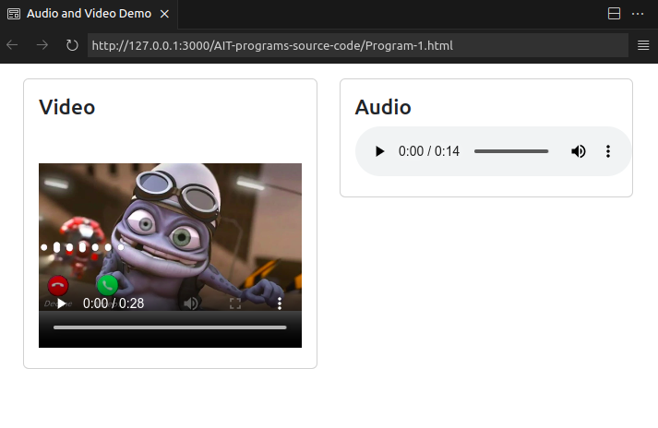
Output :
2. Program to design form using HTML5 elements, attributes and Semantics.

Ans :

<!DOCTYPE html><html>
<title>Example of Form Element and Attribute</title>
<link rel="stylesheet" href="https://cdn.jsdelivr.net/npm/bootstrap@5.3.3/dist/css/bootstrap.min.css"/>
<body>
<div class="container m-3">
<div class="card" style="width: 45rem">
<div class="card-header fs-4">Example of Form Element and Attribute</div>
<div class="card-body">
<form class="row g-3">
<div class="col-md-6">
<label for="Email Id:" class="form-label">Email Id:</label>
<input type="email" placeholder="Enter your email id." class="form-control" id="Email Id:"/>
</div>
<div class="col-md-6">
<label for="password" class="form-label">Password:</label>
<input type="password" class="form-control" id="password" placeholder="Enter password"/>
</div>
<div class="col-6">
<h4>Select gender</h4>
<div class="form-check form-check-inline">
<input class="form-check-input" type="radio" name="gender" id="inlineRadio1" value="Male"/>
<label class="form-check-label" for="inlineRadio1">Male</label>
</div>
<div class="form-check form-check-inline">
<input class="form-check-input" type="radio" name="gender" id="inlineRadio2" value="Female"/>
<label class="form-check-label" for="inlineRadio2">Female</label>
</div>
</div>
<div class="col-6">
<h4>Select subjects</h4>
<div class="form-check form-check-inline">
<input class="form-check-input" type="checkbox" id="inlineCheckbox1" name="subject[]" value="Math"/>
<label class="form-check-label" for="inlineCheckbox1">Math</label>
</div>
<div class="form-check form-check-inline">
<input class="form-check-input" type="checkbox" id="inlineCheckbox2" name="subject[]" value="English"/>
<label class="form-check-label" for="inlineCheckbox2" >English</label>
</div>
<div class="form-check form-check-inline">
<input class="form-check-input" type="checkbox" id="inlineCheckbox3" name="subject[]" value="Science"/>
<label class="form-check-label" for="inlineCheckbox3" >Science</label>
</div></div>
<div class="col-12">
<label for="description" class="form-label">Description</label>
<textarea class="form-control" id="description" rows="3"></textarea>
</div>
<div class="col-6">
<label for="inputState" class="form-label">State</label>
<select id="inputState" class="form-select">
<option selected>Select...</option>
<option value="Maharashtra">Maharashtra</option>
<option value="Gujrat">Gujrat</option>
</select>
</div>
<div class="col-6">
<label for="formFile" class="form-label">Upload</label>
<input class="form-control" type="file" id="formFile" />
</div>
<div class="col-12">
<button type="submit" class="btn btn-primary">Sign in</button>
<button type="reset" class="btn btn-outline-warning">Reset</button>
</div>
</form>
</div></div></div>
</body></html>

Output :

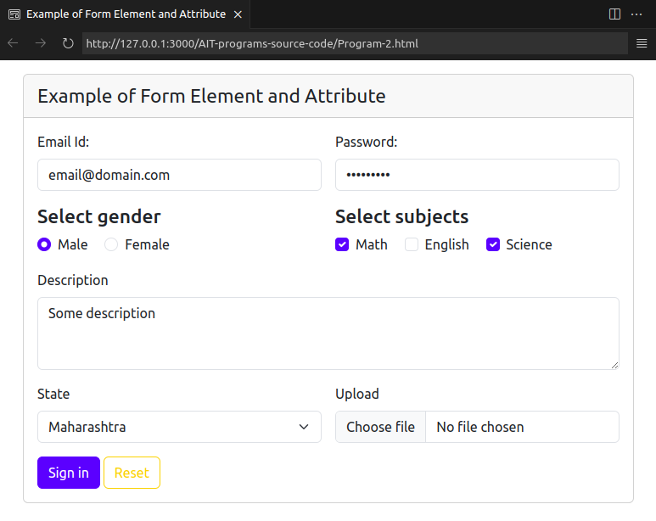
3. Program using Canvas to create Smiley face.

Ans :

<!DOCTYPE html> <html> <head>
<title> HTML CANVAS</title>
<link rel="stylesheet" href="https://cdn.jsdelivr.net/npm/bootstrap@5.3.3/dist/css/bootstrap.min.css"/>
</head><body onload="bodyLoad()">
<div class="card m-3" style="width: 18rem;"><div class="card-body">
<h1>Smiley Face</h> <br>
<canvas id="mycanvas" width="400" height="200"></canvas>
</div></div>
<script>
function bodyLoad() { myFace(); myEye(); mySmile(); }
function myFace() {
var c = document.getElementById("mycanvas");
var draw = c.getContext("2d"); draw.beginPath(); draw.fillStyle = "yellow";
draw.arc(75, 75, 50, 0, Math.PI * 2, true); draw.closePath(); draw.fill();
}
function myEye() {
var c = document.getElementById("mycanvas"); var eye = c.getContext("2d");
eye.moveTo(55, 50); eye.beginPath(); eye.fillStyle = "black";
eye.arc(50, 50, 4, 0, Math.PI * 2, true);
eye.closePath(); eye.fill(); eye.moveTo(103, 49); eye.beginPath();
eye.fillStyle = "black"; eye.arc(100, 50, 4, 0, Math.PI * 2, true);
eye.closePath(); eye.fill();
}
function mySmile() {
var c = document.getElementById("mycanvas");
var smile = c.getContext("2d"); smile.moveTo(105, 75);
smile.beginPath(); smile.strokeStyle = "red";
smile.arc(75, 75, 30, 0, Math.PI, false); smile.stroke();
}
</script></body> </html>
Output :
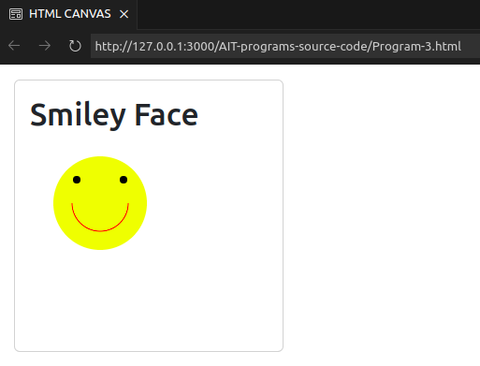

4. Program to demonstrate Radial Ingredient using SVG.

Ans :

<!DOCTYPE html>
<html>
<head>
<title>SVG Demo</title>
<link rel="stylesheet" href="https://cdn.jsdelivr.net/npm/bootstrap@5.3.3/dist/css/bootstrap.min.css"/>
</head>
<body>
<div class="card m-3 ms-5" style="width: 18rem;">
<div class="card-body">
<h2 align = "center">HTML5 SVG</h2>
<svg height ="200" xmlns = "http://www.w3.org/2000/svg">
<defs>
<radialGradient id="rg" cx="50%" cy="50%" r="50%" fx="50%" fy="50%">
<stop offset="0%" style="stop-color:rgb(255,255,0); stop-opacity:0" />
<stop offset="100%" style="stop-color:rgb(230, 100, 25);stop-opacity:1" /> </radialGradient>
</defs>
<ellipse cx = "120" cy = "50" rx = "100" ry="50" fill="url(#rg)"/>
</svg>
</div>
</div>
</body>
</html>

Output :

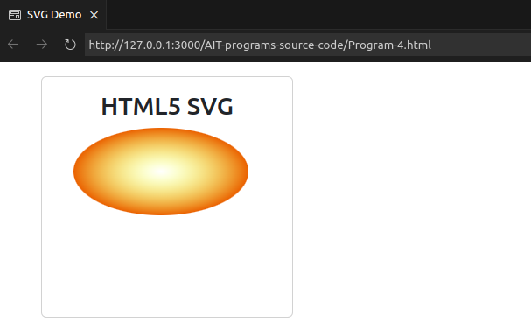
5. Programs to demonstrate external styles in the web page using font, text, background, borders and opacity properties.

Ans :

<!DOCTYPE html><html><head>
<link rel="stylesheet" href="https://cdn.jsdelivr.net/npm/bootstrap@5.3.3/dist/css/bootstrap.min.css"/>
<style>
.class1 {
color: #009900;
font-size: 50px;
font-weight: bold;
}
#s1 {
font-style: bold; font-size: 20px;
display: table-cell;
margin: 10;
background: black;
color: white;
padding: 20px;
border: 10px solid white;
vertical-align: middle;
}
p.dotted {border-style: dotted;}
p.dashed {border-style: dashed;}
p.solid {border-style: solid;}
p.double {border-style: double;}
div {background-color: #4caf50;padding: 10px;}
div.first { opacity: 0.1;}
div.second { opacity: 0.3;}
div.third { opacity: 0.6;}
</style>
</head>
<body>
<div class="container p-0 my-3" style="background: powderblue;">
<div class="main text-center">
<div class="class1">External CSS Demontrate</div>
<div id="s1">
Demonstrate external styles in the web page using font, text,
background, borders and opacity properties
</div>
</div>
<p class="dotted">A dotted border.</p>
<p class="dashed">A dashed border.</p>
<p class="solid">A solid border.</p>
<p class="double">A double border.</p>
<div class="first"><p>opacity 0.1</p></div>
<div class="second"><p>opacity 0.3</p></div>
<div class="third"><p>opacity 0.6</p></div>
<div><p>opacity 1 (default)</p></div>
</div>
</body></html>
Output :

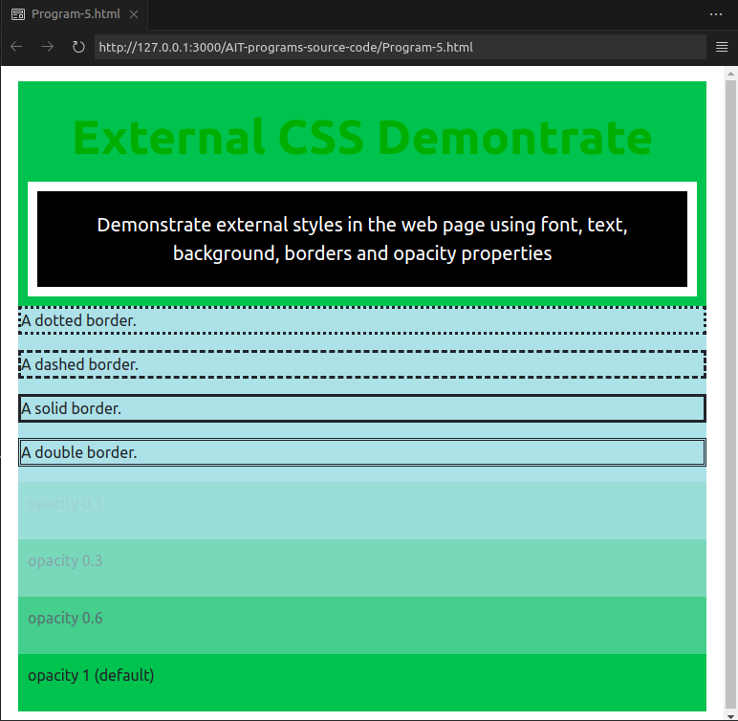

6. Programs to demonstrate any 3 CSS3 Pseudo-classes properties using internal styles in the web page.

Ans :

<html><head>
<title>Pseudo Demo</title>
<style>
a:link { color: green;}
a:visited { color: red;}
a.high:hover { color: black; cursor: progress;}
a:active { color: yellow;}
p.high:hover { color: white; font-family: Arial; background-color: red;}
div { background-color: green; color: white; padding: 25px; text-align: center; font-size: 40px;}
div:hover {background-color: blue;}
</style>
</head>
<body style="width: 500px;border:1px solid gray; padding:10px;">
<a href="hello.html" class="high">Hover to see effect</a>
<p class="high">This is Pseudo Class and CSS class Demo</p>
<p>Mouse over the div element below to change its background color:</p>
<div>Mouse Over Me</div>
</body></html>

Output :

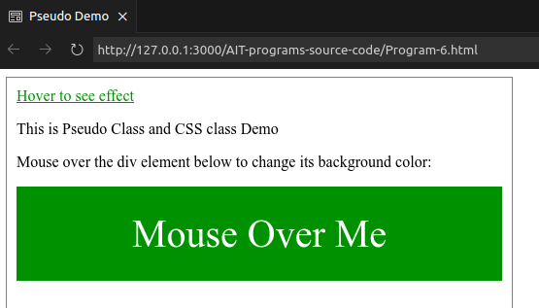

7. Program to implement Transformation using Translation, Rotation and Scaling in your web page.

Ans :

<!DOCTYPE html><html lang="en"> <head>
<link rel="stylesheet" href="https://cdn.jsdelivr.net/npm/bootstrap@5.3.3/dist/css/bootstrap.min.css"/>
<title>Transform Examples</title><style>
.box {width: 100px;height: 50px;background-color: yellow;border: 1px solid black;margin-bottom: 20px;}
.rotate {transform: rotate(20deg);}
.skew {transform: skewY(20deg);}
.scale {transform: scaleY(1.5);}
.translate {width: 300px;height: 100px;background-color: yellow;border: 1px solid black;transform: translate(150px, -15px);}
</style>
</head><body class="container">
<div class="row container border">
<div class="col-6">
<h3 class="mb-5">Transform Examples</h3>
<div class="d-flex justify-content-between">
<div class="box rotate">Hello World! (Rotate)</div>
<div class="box skew">Hello World! (Skew)</div>
<div class="box scale">Hello World! (Scale)</div>
</div></div>
<div class=" border-start col-6">
<h2>The translate() Method</h2>
<p>The translate() method moves an element from its current position:</p>
<div class="translate">
This div element is moved 150 pixels to the right, and 20 pixels down
from its current position.
</div>
</div>
</div>
</body></html>

Output :
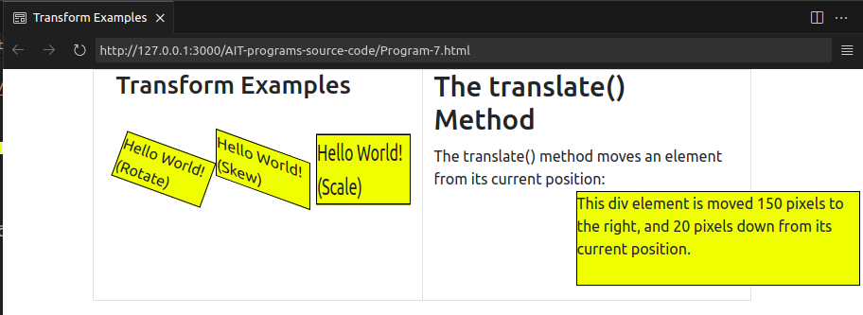
8. Program to show current date and time using user defined module in Node.JS

Ans :

// Function to convert single digit input to two digits
const formatDigit = (input) => (input > 9 ? input : `0${input}`);

// Function to convert 24-hour time to 12-hour time
const convertTo12HourFormat = (hour) => {
if (hour > 12) {
return hour - 12;
}
return hour;
};

// Get current date and time
const currentDate = new Date();

// Format date and time components
const formattedDate = {
dd: formatDigit(currentDate.getDate()),
mm: formatDigit(currentDate.getMonth() + 1),
yyyy: currentDate.getFullYear(),
HH: formatDigit(currentDate.getHours()),
hh: formatDigit(convertTo12HourFormat(currentDate.getHours())),
MM: formatDigit(currentDate.getMinutes()),
SS: formatDigit(currentDate.getSeconds()),
};

// Function to display time in 24-hour format
const displayTimeIn24HourFormat = ({ dd, mm, yyyy, HH, MM, SS }) => {
return `${mm}/${dd}/${yyyy} ${HH}:${MM}:${SS}`;
};

// Function to display time in 12-hour format
const displayTimeIn12HourFormat = ({ dd, mm, yyyy, hh, MM, SS }) => {
return `${mm}/${dd}/${yyyy} ${hh}:${MM}:${SS}`;
};

// Display time in 24-hour format
console.log("Display time in 24-hour format : " + displayTimeIn24HourFormat(formattedDate));
// Display time in 12-hour format
console.log("Display time in 12-hour format : " + displayTimeIn12HourFormat(formattedDate));

Output :

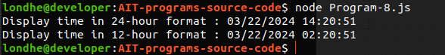

9. Program using built-in modules to split the query string into readable parts in Node.JS

Ans :

// Importing the built-in 'url' module
const url = require('url');

// Sample query string
const queryString = 'https://www.example.com/search?q=nodejs&lang=en';

// Parsing the query string using the 'url' module
const parsedUrl = url.parse(queryString, true);

// Extracting the readable parts from the parsed query string
const protocol = parsedUrl.protocol;
const hostname = parsedUrl.hostname;
const pathname = parsedUrl.pathname;
const queryParameters = parsedUrl.query;

// Displaying the readable parts
console.log('Protocol:', protocol);
console.log('Hostname:', hostname);
console.log('Pathname:', pathname);
console.log('Query Parameters:');
for (const [key, value] of Object.entries(queryParameters)) {
console.log(`\t${key}: ${value}`);
}

Output :

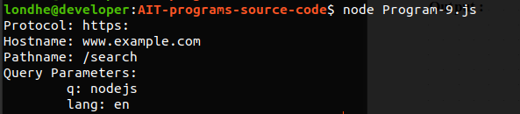

10. Program using NPM which will convert entered string into either case

Ans :

const readline = require('readline-sync');
// Function to convert string to lowercase
function convertToLowercase(str) {
return str.toLowerCase();
}
// Function to convert string to uppercase
function convertToUppercase(str) {
return str.toUpperCase();
}
// Main function
function main() {
console.log("Welcome to String Case Converter!");
const inputString = readline.question("Enter a string: ");
const option = readline.question("Convert to lowercase (l) or uppercase (u)? ");
let result;
switch (option.toLowerCase()) {
case 'l': result = convertToLowercase(inputString);break;
case 'u': result = convertToUppercase(inputString);break;
default:
console.log("Invalid option. Please choose 'l' for lowercase or 'u' for uppercase.");
return;
}
// Display the converted string
console.log(`Converted string: ${result}`);
}
// Call the main function to start the program
main();

Output :

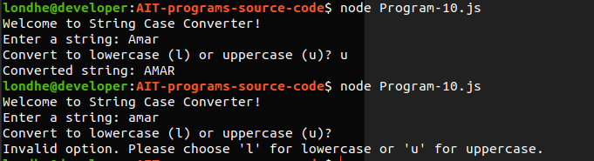

11. Write a program to create a calculator using Node JS.
Ans :

const readline = require('readline-sync');
function add(a, b) { return a + b; } // Function to perform addition
function subtract(a, b) { return a - b; } // Function to perform subtraction
function multiply(a, b) { return a * b; } // Function to perform multiplication
function divide(a, b) { if (b === 0) { return "Error! Division by zero."; } return a / b;}
function main() {
console.log("Welcome to Node.js Calculator!");
// Menu
console.log("1. Addition"); console.log("2. Subtraction");console.log("3. Multiplication");
console.log("4. Division");
const choice = parseInt(readline.question("Enter your choice: "));
let num1 = parseFloat(readline.question("Enter first number: "));
let num2 = parseFloat(readline.question("Enter second number: "));
let result;
// Perform operation based on user choice
switch (choice) {
case 1:
result = add(num1, num2);
break;
case 2:
result = subtract(num1, num2);
break;
case 3:
result = multiply(num1, num2);
break;
case 4:
result = divide(num1, num2);
break;
default:
console.log("Invalid choice.");
return;
}
console.log("Result: ", result);
}
main();

Output :

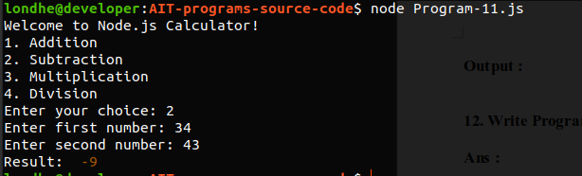
12. Write Program for Form validation in Angular.

Ans :

index.html

<!doctype html>
<html lang="en">
<head>
<meta charset="utf-8">
<title>Program12</title>
<base href="/">
<meta name="viewport" content="width=device-width, initial-scale=1">
<link rel="icon" type="image/x-icon" href="favicon.ico">
</head>
<body>
<app-root>Loading...</app-root>
</body>
</html>

main.ts

import { bootstrapApplication } from '@angular/platform-browser';
import { appConfig } from './app/app.config';
import { AppComponent } from './app/app.component';

bootstrapApplication(AppComponent, appConfig)
.catch((err) => console.error(err));

app.component.html

<div class="container">
<h1>Welcome to {{ title }}!!</h1>
<form [formGroup]="angForm" novalidate>
<div class="form-group">
<label>Name:</label><input class="form-control" formControlName="name" type="text" />
</div>
<div *ngIf="angForm.controls['name'].invalid &&(angForm.controls['name'].dirty || angForm.controls['name'].touched)" class="alert alert-danger">
<div *ngIf="angForm.controls['name'].errors.required">Name is required.</div>
</div>
<div class="form-group">
<label>Address:</label><input class="form-control" formControlName="address" type="text" />
</div>
<div *ngIf="angForm.controls['address'].invalid && (angForm.controls['address'].dirty ||angForm.controls['address'].touched)" class="alert alert-danger">
<div *ngIf="angForm.controls['address'].errors.required">email is required.</div>
</div>
<button type="submit" [disabled]="angForm.pristine || angForm.invalid" class="btn btn-success">Save</button>
</form><br />
<p>Form value: {{ angForm.value | json }}</p><p>Form status: {{ angForm.status | json }}</p></div>

app.component.ts

import { Component } from '@angular/core';
import { FormGroup, FormBuilder, Validators } from '@angular/forms';

@Component({
selector: 'app-root',
templateUrl: './app.component.html',
styleUrls: ['./app.component.css']
})
export class AppComponent {
title = 'Angular Form Validation Tutorial';
angForm: FormGroup;
constructor(private fb: FormBuilder) {
this.createForm();
}
createForm() {
this.angForm = this.fb.group({
name: ['', Validators.required ]
});
}
}

Output :

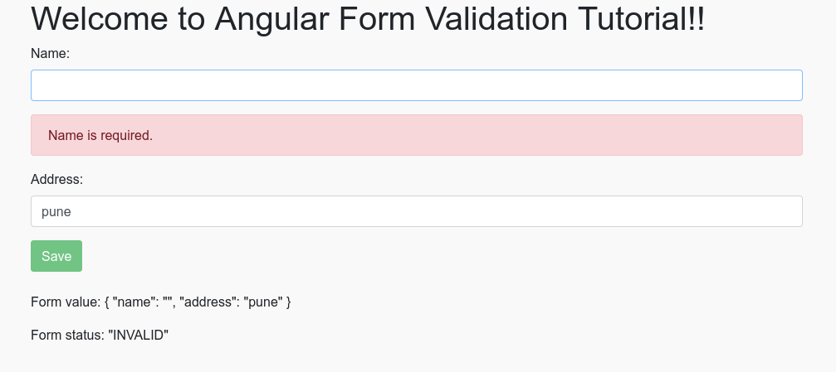

13. Program to demonstrate the ngif, ngfor, ngswitch statements.

Ans :

app.component.ts

import { Component } from '@angular/core';

@Component({
selector: 'app-root',
templateUrl: './app.component.html',
styleUrls: ['./app.component.css']
})
export class AppComponent {
title = 'HelloApp';
show = true;
show1 = false;
msg = "h1";
color1 = "blue";
arr = ["SIMCA", "MCA", "MBA", "PHD"];
Emp = [
{
Emp_id: 101,
Emp_name: "SIMCA",
Emp_sal: 12000
},
{
Emp_id: 102,
Emp_name: "SIOM",
Emp_sal: 10000
},
{
Emp_id: 103,
Emp_name: "SIBAR",
Emp_sal: 10000
}
];
}

app.component.html

<h3>*ngIf Demo</h3>
<h4 *ngIf="show">condition is true and ngIf is true.</h4>
<h4 *ngIf="!show1">condition and ngIf is true.</h4>
<h3>*ngIf and else Block Demo</h3>
<h4 *ngIf="show">condition is true and ngIf Part is true.</h4>
<h3>*nfIf and else both block demo</h3>
<h4 *ngIf="msg == 'h1'; then ifBlock else eBlock">condition is true and ngIf Part is true.</h4>
<h3>For Loop</h3>
<ol><li *ngFor="let a of arr">{{ a }}</li></ol>
<h3>EMP DATA</h3>
<table>
<tr><th>EMP_ID</th><th>EMP_NAME</th><th>EMP_SALARY</th></tr>
<tr *ngFor="let em of Emp"><td>{{ em.Emp_id }}</td><td>{{ em.Emp_name }}</td><td>{{ em.Emp_sal }}</td></tr>
</table>

Output :

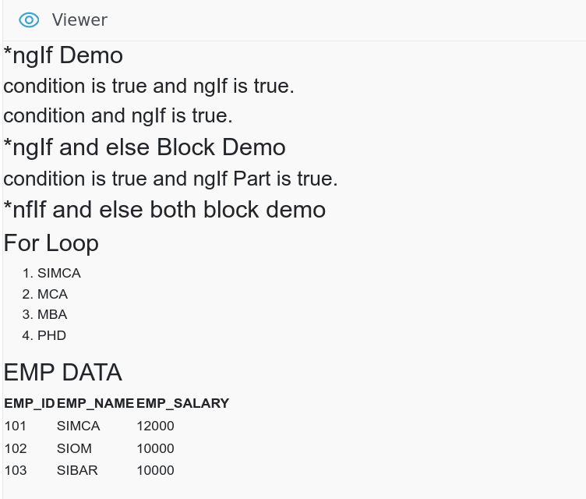

14. Create angular project which will demonstrate the usage of custom attribute directives

Ans :

highlight.directive.ts

import { Directive, HostListener, ElementRef } from '@angular/core';
@Directive({
selector: '[appHighlight]'
})
export class HighlightDirective {
constructor(private el: ElementRef) { }
@HostListener('mouseenter') onMouseEnter() {
this.highlight('yellow');
}
@HostListener('mouseleave') onMouseLeave() {
this.highlight('green');
}
private highlight(color: string) {
this.el.nativeElement.style.backgroundColor = color;
}
}

app.component.html
<div appHighlight>Hover over me to see the effect!</div>
<div appHighlight style="background-color: lightblue;">Hover over me too!</div>

app.component.ts

import { Component } from '@angular/core';
import { RouterOutlet } from '@angular/router';
@Component({
selector: 'app-root',
standalone: true,
imports: [RouterOutlet],
templateUrl: './app.component.html',
styleUrl: './app.component.css'
})
export class AppComponent {
title = 'Program-14';
}

Output :

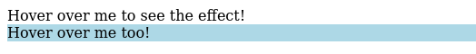

15. Create angular project which has HTML template and handle the click event on click of the button (Installation of Angular and Bootstrap 4 CSS Framework)

Install bootstrap : npm install bootstrap

Ans :

app.component.html

<div class="container">
<h3>Angular Project with Bootstrap</h3>
<h4 class="{'clickevent': clickEventText}" [textContent]="clickEventText"></h4>
<button class="btn btn-primary" (click)="handleClick()">Click me!</button>
</div>

app.component.ts

import { Component } from '@angular/core';
import { RouterOutlet } from '@angular/router';

@Component({
selector: 'app-root',
standalone: true,
imports: [RouterOutlet],
templateUrl: './app.component.html',
styleUrl: './app.component.css'
})
export class AppComponent {
title = 'Program-15';
clickEventText: string = '';

handleClick() {
this.clickEventText = 'Button clicked!';
}
}

Output :

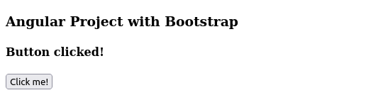

16. Create an angular project to demonstrate Single Page Application (SPA).

Ans :

app.component.html

<div class="container">
<ul class="nav">
<li class="nav-item">
<a class="nav-link active" routerLink="/" routerLinkActive="active">Home</a>
</li>
<li class="nav-item">
<a class="nav-link" routerLink="/contact" routerLinkActive="active">Contact</a>
</li>
<li class="nav-item">
<a class="nav-link" routerLink="/about" routerLinkActive="active">About</a>
</li>
</ul>
</div>

<h4>Hello, this is home page</h4>

<router-outlet></router-outlet>

app.component.ts

import { Component } from '@angular/core';
import { RouterOutlet } from '@angular/router';

@Component({
selector: 'app-root',
standalone: true,
imports: [RouterOutlet],
templateUrl: './app.component.html',
styleUrl: './app.component.css'
})
export class AppComponent {
title = 'Program-16';
}

app.module.ts
import { BrowserModule } from '@angular/platform-browser';
import { NgModule } from '@angular/core';
import { AppComponent } from './app.component';
import { HomeComponent } from './home/home.component';
import { AboutComponent } from './about/about.component';
import { ContactComponent } from './contact/contact.component';
import { RouterModule } from '@angular/router';

@NgModule({
declarations: [
AppComponent,
HomeComponent,
AboutComponent,
ContactComponent
],
imports: [
BrowserModule,
RouterModule.forRoot([
{ path: '/', component: HomeComponent },
{ path: '/about', component: AboutComponent },
{ path: '/contact', component: ContactComponent },
])
],
providers: [],
bootstrap: [AppComponent]
})
export class AppModule { }

app.component.css

.container{
background: whitesmoke;
padding: 10px ;
}
ul{
display: flex;
align-items: center;
justify-content: start;
list-style: none;
}

li{
padding-left: 10px;
}

Output :

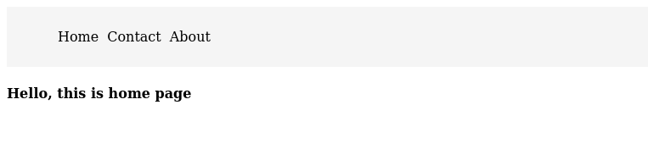

17. Program for user interface handling like form validation and taking valid value through form and displaying it to another page.
Ans :
<?php $error = "";
$name = $email = $age = ""; $showDetails = false;
if (isset($_POST)) {
if (empty($_POST["name"])) {$error .= "Name is required.<br>";} else { $name = test_input($_POST["name"]);
if (!preg_match("/^[a-zA-Z ]*$/", $name)) {$error .= "Only letters and white space allowed in name.<br>";}}
if (empty($_POST["email"])) {$error .= "Email is required.<br>";} else {
$email = test_input($_POST["email"]);
if (!filter_var($email, FILTER_VALIDATE_EMAIL)) {$error .= "Invalid email format.<br>";}}
if (empty($_POST["age"])) {$error .= "Age is required.<br>";} else {
$age = test_input($_POST["age"]);if (!is_numeric($age) || $age < 18 || $age > 100) {$error .= "Age must be a number between 18 and 100.<br>";}}}
function test_input($data) {$data = trim($data);$data = stripslashes($data);$data = htmlspecialchars($data);return $data;}
?>
<!DOCTYPE html><html><head><title>Personal Form</title></head><body>
<?php if($_POST["showDetails"] == "show"){
echo "<h3>Entered Details : </h3>";
echo "Name: " . $_POST["name"] . "<br>";echo "Email: " . $_POST["email"] . "<br>";echo "Age: " . $_POST["age"] . "<br>";
} ?>
<h2>Personal Form</h2><form method="post" action="">
<input type="hidden" name="showDetails" value="show">
Name: <input type="text" name="name" value="<?php echo $name; ?>"><br>Email: <input type="text" name="email" value="<?php echo $email; ?>"><br>
Age: <input type="text" name="age" value="<?php echo $age; ?>"><br><input type="submit" name="submit" value="Submit">
</form><div style="color: red;"><?php echo $error; ?></div></body></html>

Output :
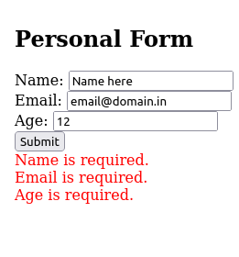

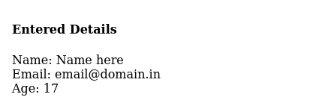

18. Program to demonstrate session management using various techniques.

Ans :

<?php
// Starting the session
session_start();

echo "<h3>Session example in php</h3>";

// Technique 1: Setting session variables
$_SESSION['username'] = 'JohnDoe';
$_SESSION['email'] = 'johndoe@example.com';

// Technique 2: Accessing session variables
$username = $_SESSION['username'];
$email = $_SESSION['email'];

// Technique 3: Checking if a session variable is set
if (isset($_SESSION['username'])) {
echo "Username is set. <br />";
} else {
echo "Username is not set. <br />";
}

// Technique 4: Removing a session variable
unset($_SESSION['email']);

// Technique 5: Destroying the session
session_destroy();

// Displaying session data
echo "Username: $username<br>";
echo "Email: $email<br>";
echo "<br />";
echo "After destroy <br/>";
echo "Email : " . $_SESSION['email'];
?>

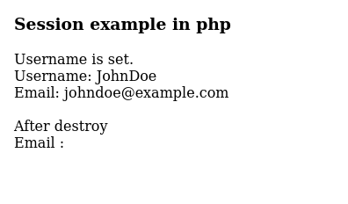
Output :

19. Program to perform the CRUD Operations using PHP Script.

Ans :

<?php
function readUsersFromFile($filename) {
$users = [];
if (file_exists($filename)) {
$data = file_get_contents($filename);
$users = json_decode($data, true);
}
return $users;
}
function writeUsersToFile($filename, $users) {
$data = json_encode($users);file_put_contents($filename, $data);
}
$filename = "users.json";
if ($_SERVER["REQUEST_METHOD"] == "POST") {
if ($_POST["action"] == "create") {
$name = $_POST["name"];$email = $_POST["email"];
$users = readUsersFromFile($filename);
$users[] = ["name" => $name, "email" => $email];
writeUsersToFile($filename, $users);echo "User created successfully.";
}elseif ($_POST["action"] == "update") {
$id = $_POST["id"]; $name = $_POST["name"];
$email = $_POST["email"]; $users = readUsersFromFile($filename);
$users[$id] = ["name" => $name, "email" => $email];
writeUsersToFile($filename, $users); echo "User updated successfully.";
}elseif ($_POST["action"] == "delete") {
$id = $_POST["id"];
$users = readUsersFromFile($filename);
if (isset($users[$id])) {
unset($users[$id]); writeUsersToFile($filename, $users); echo "User deleted successfully.";
} else {echo "User not found.";} }
} elseif ($_SERVER["REQUEST_METHOD"] == "GET") {
if ($_GET["action"] == "read") {$users = readUsersFromFile($filename); echo json_encode($users);}
$ php Program-18.php

1. Create user : User created successfully.
[ {
"name": "John Doe",
"email": "johndoe@example.com"
}]

2. Update user : User updated successfully.

[{
"name": "Jane Doe",
"email": "janedoe@example.com"
}]

3. Delete user : User deleted successfully.

[] // Blank array
}
?>

Output :

20. Program to send email to specific email id.

Ans :

<?php
// Check if the email argument is provided
if ($argc < 2) {
echo "Usage: php send_email.php <recipient_email>\n";
exit(1);
}

$to = $argv[1];
$subject = 'Test Email';
$message = 'This is a test email sent from the command line.';
$headers = 'From: amar@ourlib.in' . "\r\n" .
'Reply-To: amar@ourlib.in' . "\r\n" .
'X-Mailer: PHP/' . phpversion();

echo "Sending email to : $to\n";
echo "...........\n";
echo "\n";

if (mail($to, $subject, $message, $headers)) {
echo "Email sent successfully to $to\n";
} else {
echo "Failed to send email\n";
}

Output :

